The Change Counter
Software Requirement Specification
Gangof4 Team

Abishek Minde
Joao Carlos Almeida
Krishnan Ganesan
Nisha Narayan

Version : 1.0
Date : April 3rd, 2009

Document Revision History
Version | Date | Author | Reviewer | Updates
1.0 Draft | April 3rd, 2009 | Krishnan Ganesan | Joao Almeida | Initial Version
1.0 | April 4th,2009 | Abishek Minde | Krishnan Ganesan | Updated SRS after formal Inspection
1.1 | April 7th, 2009 | Joao Almeida | Krishnan Ganesan | Changes according to client requests.

Table of Contents
1 Introduction 5
1. Purpose 5
2. Problem Statement 5
3. Team Project Information 5
2 Functional Requirements 6
3 Requirements Classification 9
4 External Interfaces 10
1. User Interface<Joao> 10
2. Data Store Interface<Abhishek> 10
5 Design/Implementation Constraints 11
1. Counting Specifications 11
2. Header Labeling Specification <Abishek> 11
3. Formatting Specification <Joao> 11
4. General Specification <Nisha> 11
6 References 12

Introduction

Purpose
The purpose of this document is to describe the functional and quality requirements of the change counter that would serve as a guide for developers to build the system and help the end users verify if the developers are building the system that they intended.

Problem Statement
The client wishes to have a change counter tool built that would compare two versions of a file and reports the added, deleted, modified & total lines back to the user.

Team Project Information

Project | GangOf4
System | Change Counter
TSP Team# | Team 4
Roles (Cycle1) | Instructor/Client – Mel Rosso Llopart  Team Lead & Support Manager – Abishek Minde  Planning Manager – Nisha Narayan  Development Manager – Krishnan Ganesan  Quality Manager – Joao Carlos Almeida
Project Start Date | March 16th, 2009
Project End Date | May 3rd, 2009
Cycle 1 Start Date | March 20, 2009
Cycle 1 End Date | April 17th, 2009
Cycle 2 Start Date | April 18th, 2009
Cycle 2 End Date | April 29th, 2009

Functional Requirements

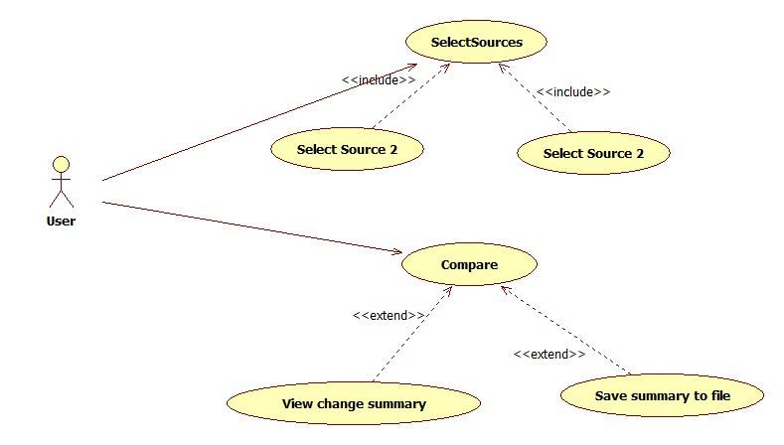

UC 1(Compare Files): The user wishes to compare two different files and receive from the system a report about the differences between these two files.
Precondition:
- The user shall inform the two files to be compared (path + file name) and the report file to be created by the system (path + file name).
- There second file will be considered the latest version.
Basic Flow
Line | System Actor Action | System Response
 | The user fulfils appropriate fields to inform the two files to be compared. | The system prompts the user to enter the name of the file along with the complete physical path.
 | The user requires the system to compare these two files. | The system start reading both files;  Make a comparison between file 1 and 2;  Produce a report (Req004);  Provide a report summary feedback on the user interface (Req004);  The use case ends.
Post condition: The system produces a new file with the results from comparison.

UC 2(Select Sources): This use case is responsible to allow the user select the files to be compared by the system. Both files informed by the user are sent to Make Comparison use case.
Precondition:
None.
Basic Flow
Line | System Actor Action | System Response
1 | User informs file names and location. | The use case open a user interface where the user can select the file to be compared;  The use case ends.
Post condition: Both file contents sent to user case “Make Comparison”.

UC 3(View Change Summary): This use case shows the change summary on the system user interface.
Precondition:
- Comparison results received from “Make Comparison” use case.
Basic Flow
Line | System Actor Action | System Response
1 | - | The use case receives comparison results and shows the change summary information on the system user interface.
Post condition: Summary report created and shown on user interface.

UC 4 (Save Summary to file): This use case saves the comparison results into a report file.
Precondition:
- Comparison results received from “Make Comparison” use case.
Basic Flow
Line | System Actor Action | System Response
1 | - | The use case receives comparison results and creates the final report (Req004).
Post condition: Final report file created with comparison results.

Requirements Classification

Functional Requirements :( Must Have)
Requirement Id | Description
REQ001 | Identify the added and deleted lines of code in the file latest version. This requirement is described in the use case UC3;
REQ002 | Count the changed line according to the following criteria: the system will compare each character in a line from the old and new file version. If more than 70% characters are different in this line, it will be counted as changed line.  This requirement is used in the use case UC3;
REQ003 | Count the total lines of code in the modified program.
REQ004 | The final report shall contain the following information:  - Comparison summary with: Comparison date; files being compared (file name); Number of lines added/deleted/changed and Total line number;  - Comparison detail: lines number with information if a line was added, deleted or changed.

Functional Requirements :( Nice to have)
- Attach line label reference for added and deleted lines of code
- Provide the change label in a program header comment indicating the change number, date, who made it ,why it was made , the added , deleted and total lines of code.
- When a previously modified program is further modified all the prior modifications records must be maintained.
- On demand, print program listing with change label and line label information
- On demand, print a program listing with line number of modified program inserted at the head of each line of code.
- On demand, print a program-change report with statistics for the modified program and all prior changes
Quality Requirements :( Must Have)
Usability (Immediate Understanding):- Needs to be elicited from the client.
Quality Requirements :( Nice to Have)
Extensibility (Multiple Language Support):- The software will initially be built to work with any one of the languages (Example Ada, C++, C, Pascal) but logic can be extended for other languages.

External Interfaces

User Interface
The user interface for the change counter tool will be a graphical interface displaying the options to the user.
File 1 – This field is used to identify the old file version to be compared (UC1).
File 2 – This field is used to identify the new file version to be compared (UC1).
Report – This field is used to identify where the final report will be created and also the name of the final report file (UC1).
Start Comparison – This button is used to start the system comparison between the two files provided by the user (UC1).
Quit – After selecting this option, the system closes.

Data Store Interface
All the information (change information) pertaining to the files comparison in the system will be maintained in a persistent data store.
The information to be reported by the system is reported on REQ004.

Design/Implementation Constraints

Counting Specifications
  - Have the LOC counter count text lines with the coding standards that requires one logical LOC to be placed on a single text line.
  - In comparing a program with its prior version the comparisons are made as follows:
    - If a line is contained in both original version 3 and modified version 4, it is an original and an unchanged line.
    - If a line is in version 4 only and not in version 3, it is an added line.
    - If a line is in version 3 only and not in version 4, it is a deleted line.
  - Count each changed line as an added and deleted line.
  - Analyze added-deleted line pairs to identify truly added-deleted lines and changed lines.
  - Moving or copying a section of code would attribute to deleting the section of lines from the original location and adding them to a new location.

Formatting Specification
In order to develop this system some standard must be followed by development team. In this section some of these standards are described and might be applied on team deliverables.

Requirements
All the requirements should be identified according to the following criteria:
REQNNN
REQ – characters used to easily identify a requirement;
NNN – three digits number for requirement unique identification;
Example: REQ001 – The system shall count the number of added code lines.

Design
The development team will use UML diagrams to represent the system architecture. The following diagram can be used to make this representation
- Class diagram – this diagram must be used to represent the classes to be created to build the system.
- Activity diagram – this diagram can be used in complex classes to detail the activities to be performed by classes’ methods. This diagram is optional and will be under developer criteria the need to create or not this diagram.

Language
In order to gain system platform flexibility the programming language to be used on the project will be Java.

Coding
In order to our system be able to correctly evaluate a code file, programmers might follow the standards describe in this document. Otherwise is not guaranteed that system evaluation about a code file will represent correct information regarding added, deleted and changed lines of code.
Here are some standards that should be respected on the files to be controlled by the system:
- Avoid more than one command per line – programmer should avoid using more than one method or function per line of code;
- Comments will not be counted as line of code;
- Avoid using multi-line comment tags like “/* */”, instead use single line comments, like “//”;
- Empty lines will not be counted as line of code;

General Specification
Language Support: The Change Code Counter will work only for programs written in Java.
User interface: The product will have a command line user interface.
Platform: The product will run on operating systems that can run the Java Runtime Environment.

References

- Chapter 6 – Defining the Requirements, Introduction to Team Software Process, Watts Humphrey.

